# DAD 220 Module Three Major Activity Template

## Overview

Complete these steps as you work through the directions for this activity. Replace the bracketed text with a screenshot and brief explanation where indicated. Each screenshot and its explanation should be sized to approximately one-quarter of the page with the description written below the screenshot. Review the Template Screenshot Example linked in the guidelines and rubric for this assignment to see how screenshots for your assignment should look.

## Create a Database

1. In your online integrated development environment (Codio), **create a database schema** called Quantigration RMA that can hold tables.
   1. List the database name on the screen.
   2. Provide the SQL commands you ran to successfully complete this step.



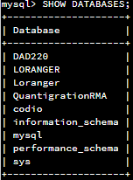

1. Connect to the Quantigration RMA schema. **Create** the following **tables with the appropriate attributes and keys** in the Quantigration RMA database using the Quantigration RMA Entity Relationship Diagram (ERD) as a reference:
   1. A table named **Customers** to store customer information with a primary key of Customer ID
      1. Provide the SQL commands you ran against MySQL to complete this successfully in your answer:



Based on the ER Diagram, the respective field names and formatting were created, with the primary key being declared to be the CustomerID field.

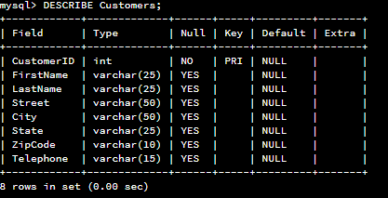

* 1. A table named **Orders** to store order information with a primary key of Order ID and foreign key of Customer ID
     1. Provide the SQL commands you ran against MySQL to successfully complete this step.



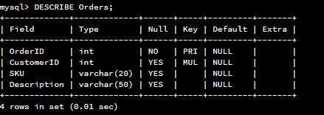

* 1. A table named **RMA** to store RMA information with a primary key of RMA ID and foreign key of Order ID
     1. Provide the SQL commands you ran against MySQL to successfully complete this step.



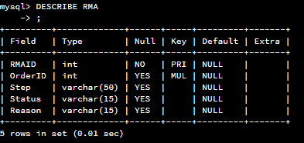

The table parameters were pulled from the ER diagram, with Primary key and Foreign keys assigned respectively.

1. Manually **add 10 records** into the **Customers table**. For now, you can make up data. In a later assignment, you will use the CSV files provided to fill in all three tables.

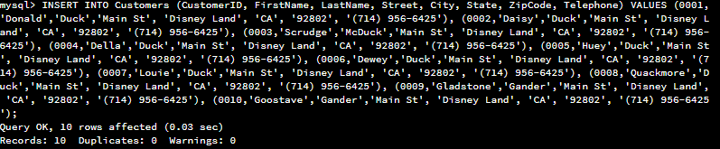

Seems the Donald Duck family tree really likes something this company sells! Odd they all live at the same address but put in separate orders; maybe it’s Christmas time so they are trying to hide from each other their presents?

1. You’ve been asked to establish a database view called Collaborators based on the Customers table. **Create** the **Collaborators View** from theexisting Customers tableby using the SQL command belowto say "Collaborators". The view should show all instances of "Customer" renamed as "Collaborator". Execute the following statements and provide one or more supporting screenshots showing the database view.
   1. The following command is partially complete. Fill in the missing information in the brackets to complete then command and run it correctly:

CREATE VIEW Collaborators AS

SELECT

CustomerID AS CollaboratorID,

FirstName,

LastName,

Street,

City,

State,

ZipCode,

Telephone

FROM Customers;

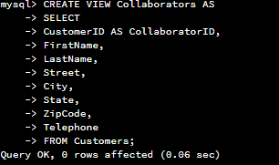

The output of this step is not very clear if only the header was supposed to be renamed, or if the data inside should be printed as “Collaborator”. Given the ‘Customer’ text was called out, the only instance of that text was in the already provided ‘CustomerID’ field name. All other fields were left alone as they did not contain the ‘Customer’ phrase.

Also note that the instructions said the view should be ‘Collaborators’ (plural form), while the commands provided used the singular form. The commands were updated accordingly to use the plural version.

* 1. DESCRIBE Collaborators;

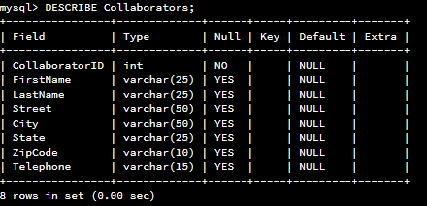

* 1. SELECT * FROM Collaborators LIMIT 5;

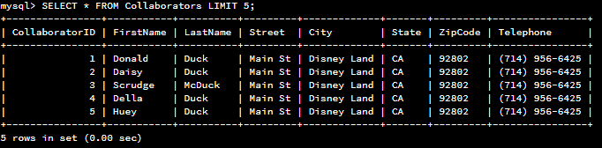

View successfully created with the Primary key displayed as “CollaboratorID” instead of “CustomerID” as the table is created.

Select command chooses only the first 5 results.

